Digifort App Installation for PC based DVRs
This app is neither developed nor maintained by Optiview. We provide this manual only as a courtesy to our valuable customers
Customer who wishes to view their PC based DVRs on-line through their Android mobile device or tablet must follow these instructions step by step.
- First you need to make sure your router has the appropriate ports forwarded and open to be used with this mobile app. The port that will need to be forwarded is 80 OR 81, 82, 84 (if 80 is blocked by your ISP provider). If you have any more questions about this, please refer to your router manual or internet service provider before you proceed to the next steps.

- Go to Google Play Store on your Android device and in the search bar you will type in Digifort, and press enter; You should see a search result page like the one bellow.

Click on the MVR-HD icon
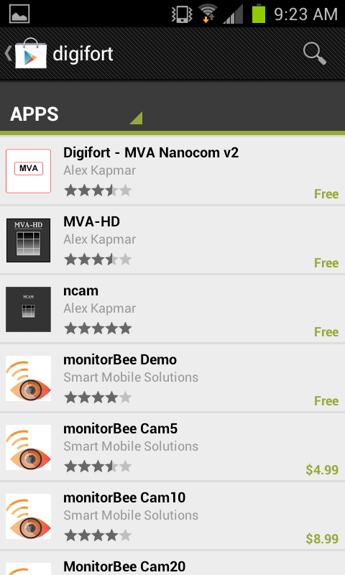

- Click Install
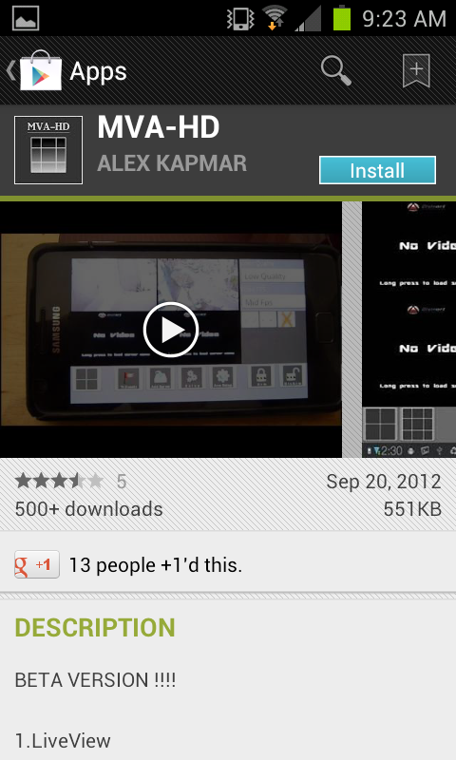

- Click Accept and Download
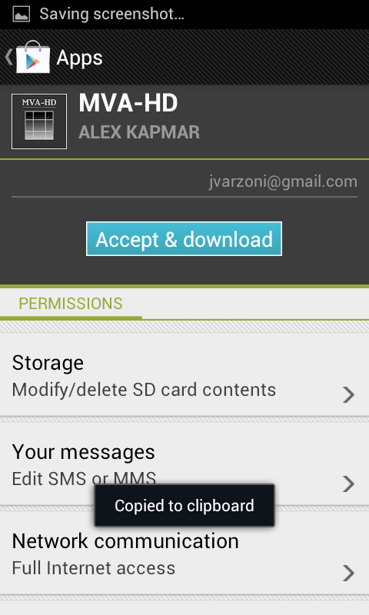
- After the install is completed, the app icon will be placed on your android device. You must go to the app screen where all of the other apps are placed on your android device and click on this icon:
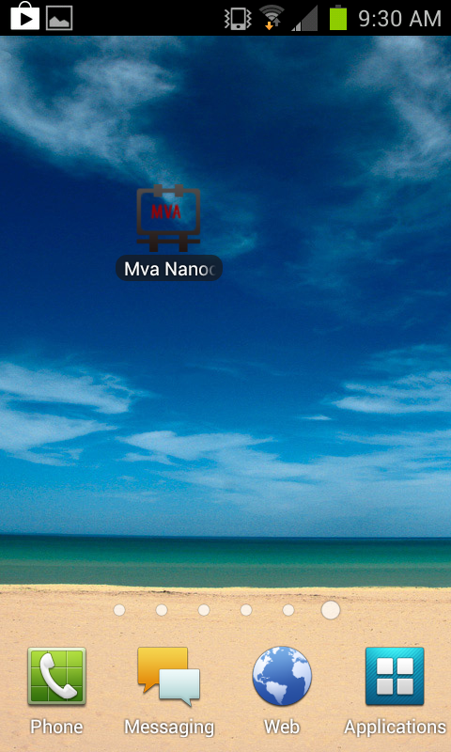

- The next screen will look like the image bellow.
Click the Add Server button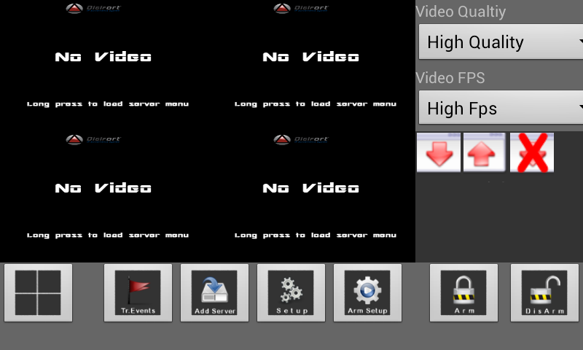

- Click the menu button on your phone and then click the Add New Server option at the bottom.
The next screen will show up; Input the DVR’s settings in the fields shown.
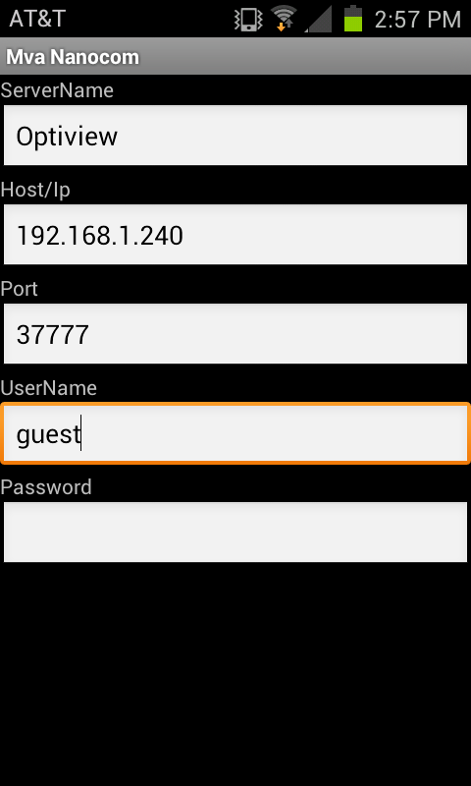
Click the phone’s menu button again and then click Save.

- Click the back button on your phone until you get back to the first screen.

- Click AND HOLD one of the four little screens to select a camera.
A popup menu will show up where you can choose from which server you want to see (you may have multiple servers setup. If you have just one, only one option will appear like in the example bellow). Click OK
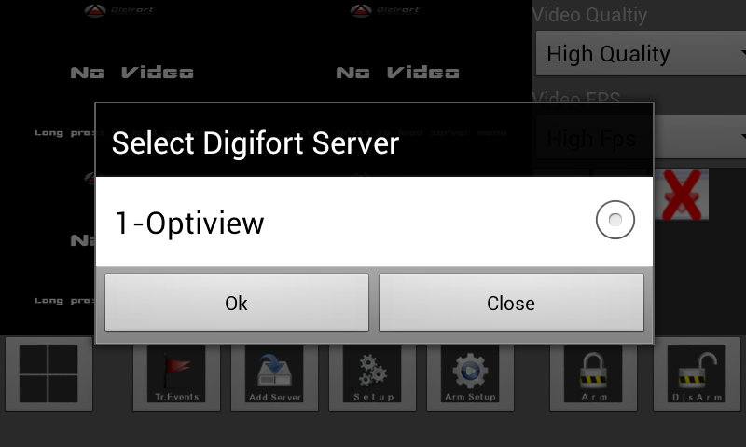
- A new popup will appear where you can choose the specific camera you want to see.
Choose a camera and click Ok
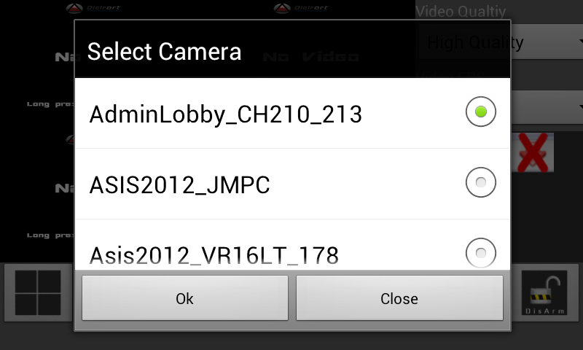

- You now can see the selected camera. Follow the same steps if you want to see another camera in any of the other three selectable “squares”.
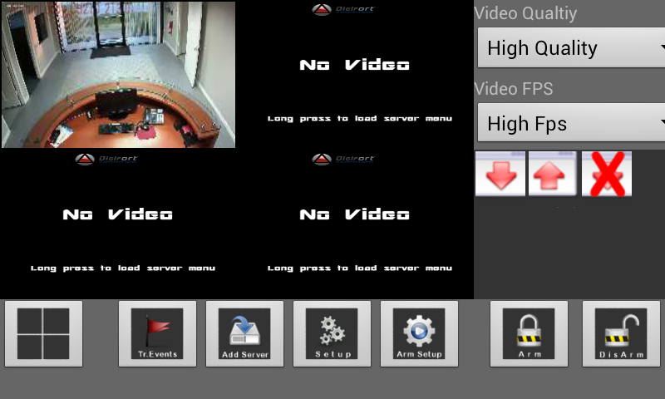

Obs.: You can double click any of the cameras being shown to see it in full screen mode.

